**SEARCH FUNCTIONALITY**

**Technical Documentation**

**Joshua Cervantes**

**Table of Contents:**

## Beginning

## Valid Majors

## Selection Option

## NEXT

## Search Feature

## Major

## Graduation Date

## Partial View

## Rendering

## Rails Logger

**To begin:**

**Valid Majors-**

1. Add a constant array named “Valid Majors” to your app/model/student.rb, which will make sure there is a list of accepted majors



1. Then add validation, that will make sure the major selected by the user is in the list

**Selection Option-**

To create a dropdown menu containing a list of the majors we added above, we need to add a selection option in our app/views/students/_form.html.erb. To do this we need to add a new section within form.html separating it with <div> and </div>. From there add these lines: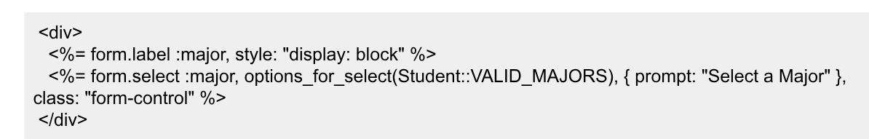

form.select will create the dropdown and options will be generated along with a prompt telling the user to “Select a Major”.

**NEXT:**

**Search Feature-**

Within our student controller: app/controllers/students_controller.rb, we need to add a way to get data from a form field as a hash to know what attribute and value to search for then store it in our search parameters. To do so add this: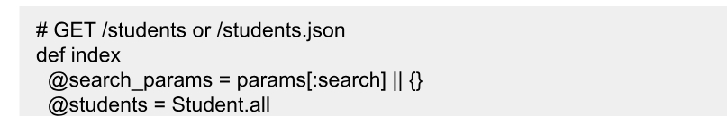

**Major-**

Then when a search is done, we need to check if the search was present. In this case we are searching for present majors and will use ORM of active record to query the database. Add this line underneath the line above: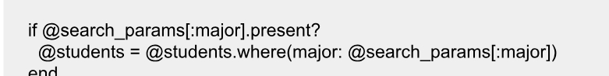

**Graduation Date-**

To add a graduate date search check within the controller, we need to check if the search for the graduation date was present. We should also add a new variable (Date_filter) which will check if the date of graduation is before or after a certain date. Add this below the code for major checking:

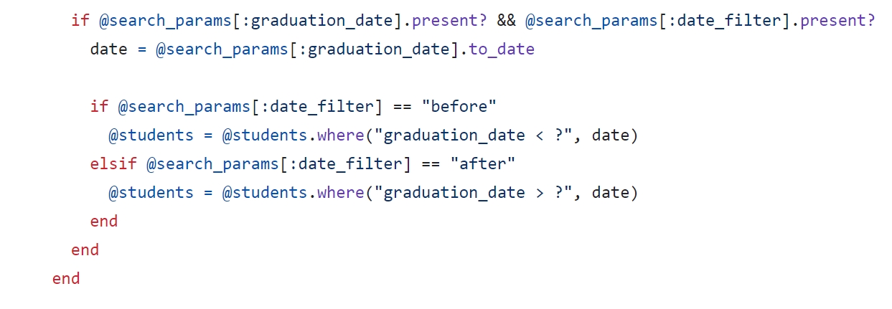

**Partial View-**

To see the search form as a new page we need to create a partial search form fragment in views and add the _search_form.html.erb file: app/views/students/_search_form.html.erb

Add this to that search form file:

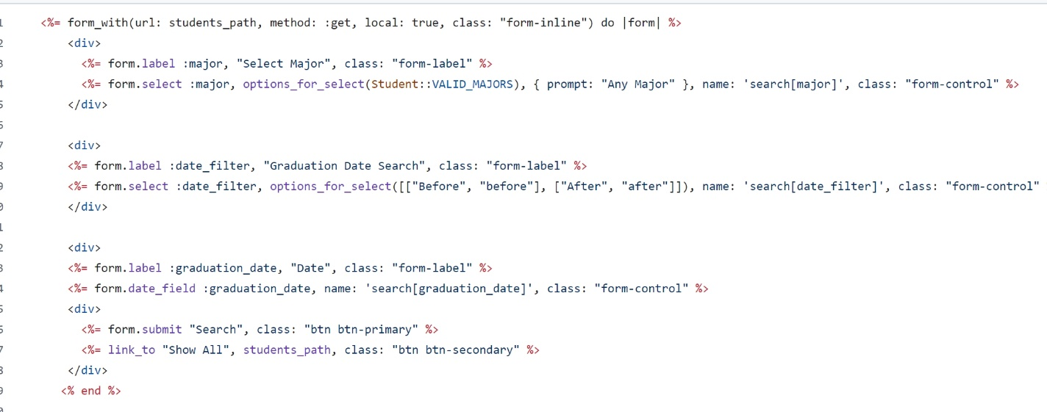

This will give you all the forms needed to select options for majors, graduation date and add a search button.

**Rendering-**

Then to render this search form, go to app/views/students/index.html.erb, and add this:

Once this is all set up, your search form on the server should look something like this. Styling will come from bootstrap:

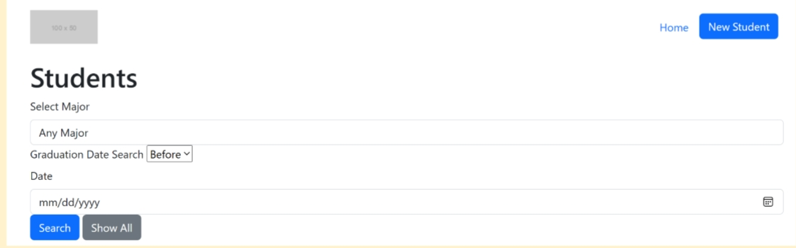

**Rails Logger-**

To add logging information and see what is actually in the search parameters, we can add this code to our app/controllers/students_controller.rb:

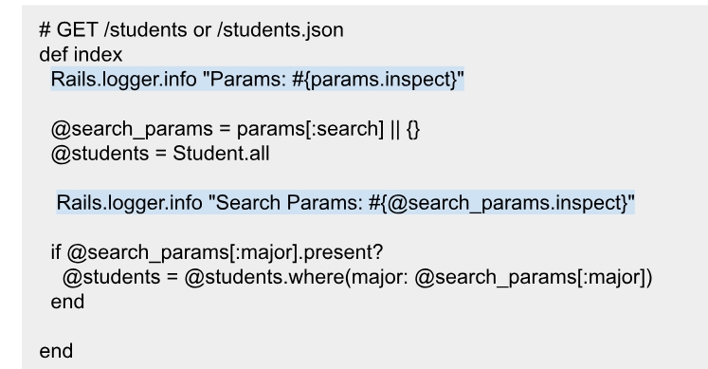

You’ll be able to see the log information in log/development.log and you can also see it in the command line when you run the server.